EZ vs EZ+bias recovery results
data simulated from a full 7-parameter DDM, adding a free starting point to the hierarchical EZ model removes the non-decision-time bias and brings most parameters close to their true values
there is some error in the starting point (overestimated by about 0.025) and the drift intercept (about 13% too low)
10 replications, each 100 persons × 200 trials (100 per condition), simulated trial by trial with rtdists::rdiffusion from a full 7-parameter DDM
Parameter | Population value | Between-person SD
Drift intercept | 1.30 | 0.20
Condition effect on drift (±1 coding) | 0.50 | 0.30
Boundary separation (log scale) | log(1.5) = 0.405 | 0.08
Non-decision time t0 | 0.20 s (mean NDT 0.23 s) | 0.05 s
Starting point w (logit scale) | 0.55 (logit 0.20) | 0.25
Drift variability sv | 0.50 | —
Starting-point variability sw | 0.15 | —
NDT variability st0 | 0.3 × t0 | —

Models have the same priors derived from a 20-person pilot of another rep
- EZ: drift = intercept + condition (both random), log boundary and non-decision time (random intercepts) accuracy, mean and variance of correct RTs per cell
- EZ+bias: the same model plus a random starting point on the logit scale, translated from the JAGS model number of upper responses, the mean RTs of upper and lower responses, and the variance of all RTs per cell
Because st0 is missing, both estimate the mean non-decision time (1.15 × t0), so tau is compared with the mean NDT
All 10 reps converged for both models: 4 chains × 1,000 post-warmup draws, no divergences, no max-treedepth hits, maximum Rhat 1.016.
Rep | EZ max Rhat | EZ min bulk ESS | EZ+bias max Rhat | EZ+bias min bulk ESS
01 | 1.006 | 1117 | 1.008 | 533
02 | 1.008 | 586 | 1.008 | 447
03 | 1.006 | 1180 | 1.009 | 399
04 | 1.007 | 628 | 1.005 | 527
05 | 1.006 | 966 | 1.004 | 490
06 | 1.006 | 685 | 1.016 | 437
07 | 1.007 | 1092 | 1.014 | 535
08 | 1.005 | 1065 | 1.008 | 676
09 | 1.005 | 877 | 1.005 | 405
10 | 1.005 | 1074 | 1.006 | 494

EZ+bias mixes more slowly (bulk ESS roughly half of EZ's), probably because starting point and drift are correlated, but every ESS is above 390

Population-level recovery
EZ+bias is closer to the truth than EZ for 6 of the 8 shared parameters but it is worse for the drift intercept and slightly worse for the boundary mean
Estimates are posterior means averaged over the 10 reps (range across reps in brackets)
coverage is the share of reps whose 90% interval contains the true value
Parameter | True | EZ estimate | EZ coverage | EZ-+bias estimate | EZ+bias coverage
Non-decision time (mean NDT, s) | 0.230 | 0.195 [0.185–0.207] | 0.0 | 0.231 [0.219–0.244] | 0.9
SD non-decision time (s) | 0.0575 | 0.065 [0.057–0.074] | 0.6 | 0.056 [0.049–0.065] | 0.9
Condition effect on drift | 0.50 | 0.443 [0.409–0.479] | 0.4 | 0.465 [0.433–0.499] | 0.9
SD drift intercept | 0.20 | 0.267 [0.235–0.295] | 0.0 | 0.223 [0.174–0.255] | 0.8
SD boundary (log) | 0.08 | 0.094 [0.077–0.110] | 0.3 | 0.090 [0.072–0.103] | 0.6
SD condition effect | 0.30 | 0.301 [0.247–0.359] | 0.8 | 0.310 [0.253–0.374] | 0.7
Boundary mean (log) | 0.405 | 0.396 [0.383–0.411] | 0.7 | 0.384 [0.369–0.402] | 0.4
Drift intercept | 1.30 | 1.33 [1.27–1.40] | 0.8 | 1.13 [1.07–1.17] | 0.0
Starting point w (median, 0–1) | 0.55 | — | — | 0.575 [0.562–0.588] | 0.1
Starting point w (logit mean) | 0.201 | — | — | 0.301 [0.250–0.354] | 0.1
SD starting point (logit) | 0.25 | — | — | 0.254 [0.204–0.296] | 1.0

Bold numbers mark the model that closer to the true value
The boundary difference is small on the natural scale: exp(0.384) = 1.47 against a true 1.50

Person-level recovery
EZ+bias recovers every person-level parameter at least as well as EZ in correlation, and basically removes the tau bias
the drift intercept is the exception, it is shifted down by 0.17
Values are averaged over the 10 reps (correlation, bias and RMSE computed per rep)
Parameter | EZ r | EZ bias | EZ RMSE | EZ+bias r | EZ+bias bias | EZ+bias RMSE
Non-decision time (vs | 0.80 | −0.034 | 0.050 | 0.88 | +0.003 | 0.028
Condition effect on drift | 0.86 | −0.058 | 0.163 | 0.87 | −0.035 | 0.153
Boundary (log) | 0.75 | −0.011 | 0.060 | 0.79 | −0.022 | 0.057
Drift intercept | 0.67 | +0.031 | 0.187 | 0.71 | −0.168 | 0.225
Starting point w (0–1) | — | — | — | 0.77 | +0.023 | 0.046

EZ (all 10 reps pooled):
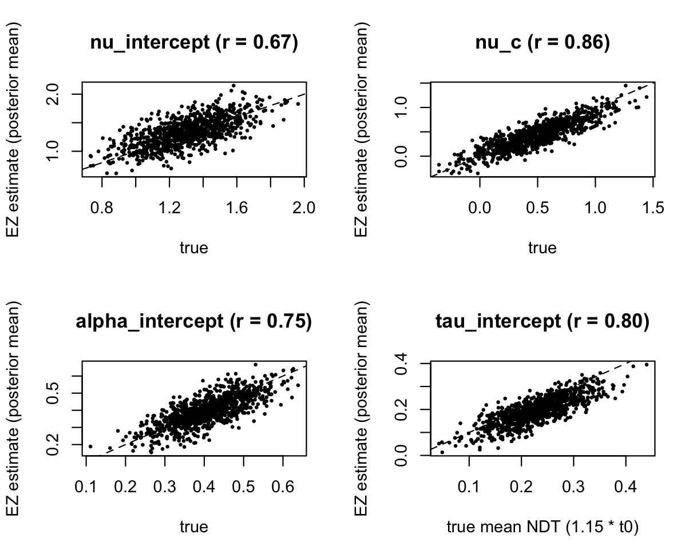

EZ+bias (also pooled):
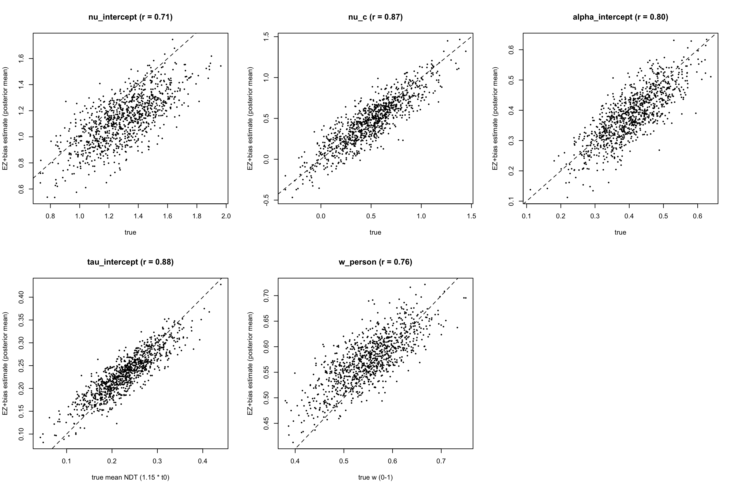
EZ: tau sits below the diagonal across the whole range
EZ+bias: tau recovers better, but the drift intercept underestimates and w shows regression to the mean
EZ without a bias parameter: a start closer to the correct boundary makes correct responses faster and raises accuracy most in the hard condition. EZ absorbs this into its other parameters: tau is 0.035 s too low, the condition effect is 11% too small, and person differences in bias inflate the drift-intercept SD (0.27 vs 0.20)
When we estimate the bias, tau, its SD, the condition effect and the drift-intercept SD all become closer to the truth, and the SD of the bias is recovered well (0.254 vs 0.25)

